Topic 6.7: Combination Sum Problem
Question
Given an array of distinct integers candidates and a target integer target, return a list of all unique combinations of candidates where the chosen numbers sum to target.
- The same number may be chosen from candidates an unlimited number of times.
- Two combinations are unique if the frequency of at least one chosen number is different.
- The number of unique combinations is guaranteed to be less than 150.
Aim
To generate all unique combinations of candidate numbers that sum to a given target using backtracking.
Algorithm
- Sort the candidates for consistent combination building.
- Define a recursive function that:
  - Keeps track of the current sum and the current combination.
  - If the sum equals the target, stores the combination.
  - If the sum exceeds the target, backtrack.
- At each step, try including the current candidate (with unlimited use).
- Move to the next candidate to avoid duplicate combinations.
- Return all valid stored combinations.
Output
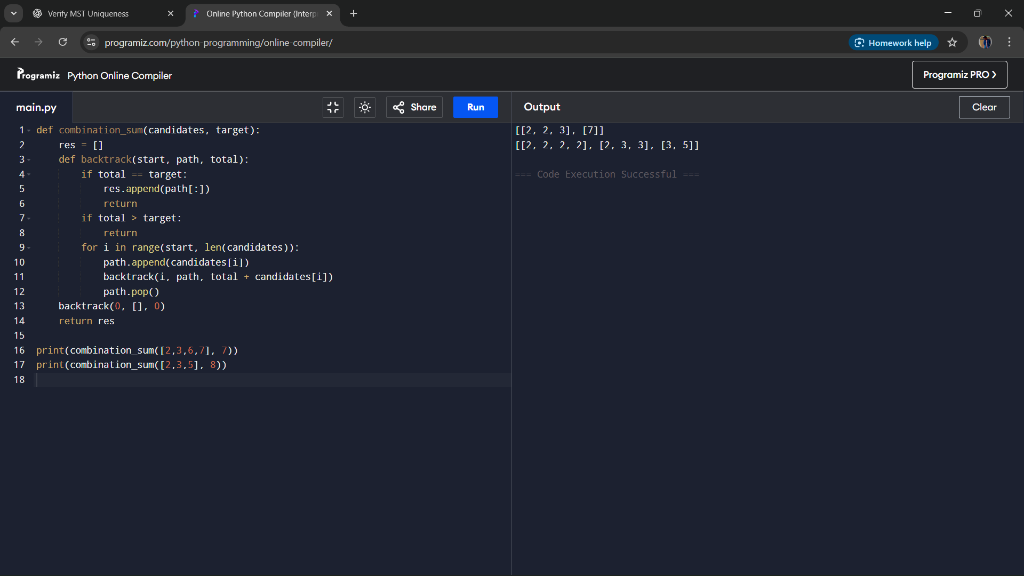
Result
The program successfully finds all unique combinations of numbers that sum to the target, allowing unlimited reuse of elements.
Performance Analysis
- Time Complexity: O(2^t), where t is the target value, due to exploring subsets.
- Space Complexity: O(t) for recursion stack and storing combinations.

